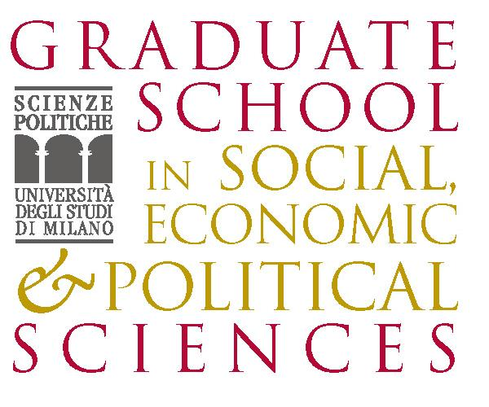  http://www.graduateschool.unimi.it |   http://www.dagliano.unimi.it |   http://www.cepr.org |   UNIVERSITA’ DEGLI STUDI DI TORINO  SCUOLA DI DOTTORATO IN ECONOMIA “VILFREDO PARETO”  http://www.sde.unito.it/indexIT.htm

SIXTH SUMMER SCHOOL

IN INTERNATIONAL AND DEVELOPMENT ECONOMICS

International Migration and the Host Country

Sunday 9 September to Wednesday 12 September 2007

University of Milan, Palazzo Feltrinelli, Gargnano (BS), Italy

Application form

Title (Mr/Mrs): | First name:
Family name:
Nationality: |  | Date of birth:
University:
University address:
Private address:
E-mail address:
Phone: |  | Fax:
Title of dissertation:
Supervisor:
Thesis completion date (past or expected):
I request funding* YES NO

* A limited number of grants is available. Therefore only applicants coming from Developing Countries and Transition Countries will be eligible for funding. To obtain the reimbursement applicants must attend the whole course.

Please submit this application along with your CV by May 31, 2007 to: centro.dagliano@unimi.it

The school is organised as part of the Marie Curie Research Training Network on ‘Transnationality of Migrants’

The activities of the Centro Studi  Luca d’Agliano are supported by   | The Marie Curie Research Training Network on ‘Transnationality of Migrants’  is funded by the European Commission  

www.dagliano.unimi.it

