 | 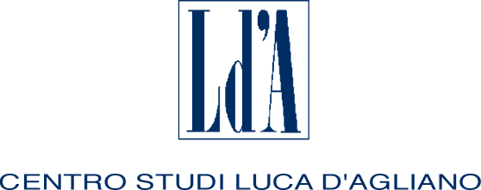 |  | 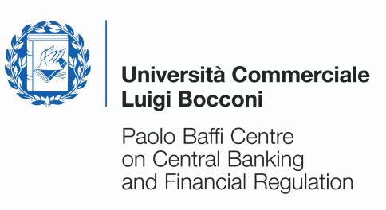 |  | 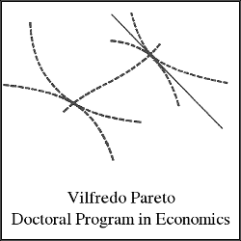  UNIVERSITA’ DEGLI STUDI DI TORINO
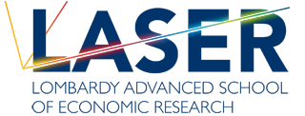 |  |  |  | 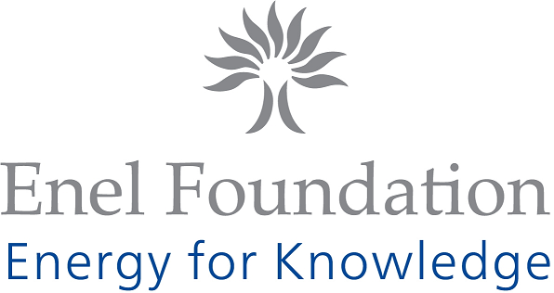

TWELFTH SUMMER SCHOOL

IN INTERNATIONAL AND DEVELOPMENT ECONOMICS

Gravity Rules in the Modern World Economy

Wednesday 11 September to Saturday 14 September 2013

University of Milan, Palazzo Feltrinelli, Gargnano (BS), Italy

Application form

First name: | Family name:
Nationality: | Date of birth: |  | Sex:
University:
E-mail address:
Phone: |  | Fax:
Title of dissertation:
Supervisor:
Thesis completion date (past or expected):

I request funding* YES NO
* A limited number of grants is available. Therefore only applicants coming from Developing Countries will be eligible for funding. To obtain the reimbursement applicants must attend the whole course.

Please submit this application along with your CV by May 24, 2013 to: centro.dagliano@unimi.it
The activities of the Centro Studi Luca d’Agliano are supported by


www.dagliano.unimi.it

