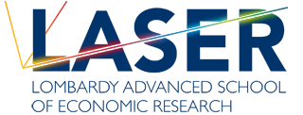 |  | 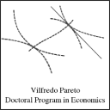 | 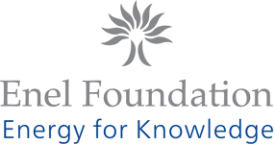

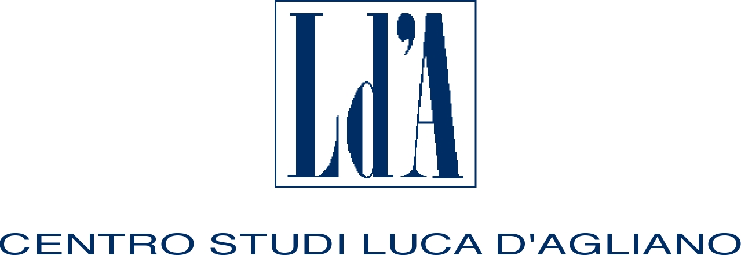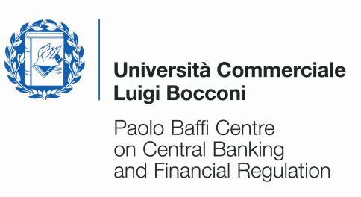

ELEVENTH SUMMER SCHOOL
IN INTERNATIONAL AND DEVELOPMENT ECONOMICS

Cities, Productivity and Migration

Wednesday 27 June to Saturday 30 June 2012

University of Milan, Palazzo Feltrinelli, Gargnano (BS), Italy

Application form

First name: | Family name:
Nationality: | Date of birth: |  | Sex:
University:
E-mail address:
Phone: |  | Fax:
Title of dissertation:
Supervisor:
Thesis completion date (past or expected):

I request funding* YES NO

* A limited number of grants is available. Therefore only applicants coming from Developing Countries will be eligible for funding. To obtain the reimbursement applicants must attend the whole course.

Please submit this application along with your CV by May 13, 2012 to: centro.dagliano@unimi.it

The activities of the Centro Studi Luca d’Agliano are supported by


www.dagliano.unimi.it

