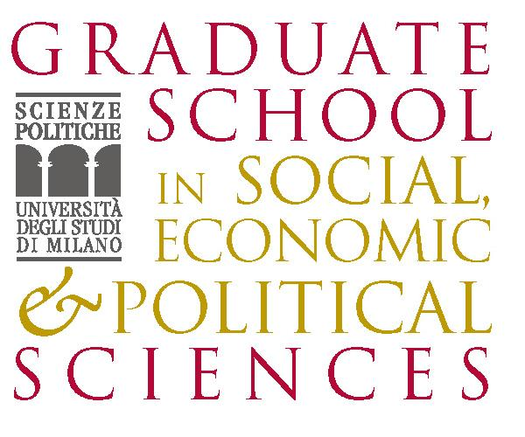  http://www.graduateschool.unimi.it |   http://www.dagliano.unimi.it |   http://www.cepr.org | 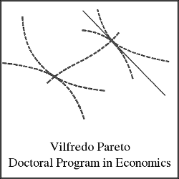  UNIVERSITA’ DEGLI STUDI DI TORINO  http://www.sde.unito.it/index.html

TENTH SUMMER SCHOOL

IN INTERNATIONAL AND DEVELOPMENT ECONOMICS

The Political Economy of Trade in Services

Sunday 18 to Wednesday 21 September 2011

University of Milan, Palazzo Feltrinelli, Gargnano (BS), Italy

Application form

Title (Mr/Mrs): | First name:
Family name:
Nationality: |  | Date of birth:
University:
E-mail address:
Phone: |  | Fax:
Title of dissertation:
Supervisor:
Thesis completion date (past or expected):

Students are expected to attend the school full time. Accommodation and meals will be provided during the Summer School free of charge.

- I am a GIST Early Stage or Experienced Researcher at the time of the summer school
Contract start date: Contract end date:
Early Stage Researchers and Experienced Researchers employed in the GIST network at the time of the summer school will cover their travel expenses using their Participation Allowance budget.

- I am a former GIST Early Stage or Experienced Researcher YES NO
I require travel funding YES NO
Former GIST Early Stage Researchers and Experienced Researchers are strongly encouraged to apply. There will be some funding available to cover their travel expenses.

- For students not part of the GIST network – I require travel funding YES NO
Some travel funding will be available also to students not part of the GIST network. Priority will be given to students from Developing Countries.

Please submit this application along with your CV by May 27, 2011 to: centro.dagliano@unimi.it

The school is organised as part of the Marie Curie Initial Training Network on ‘Globalisation, Investment and Services Trade (GIST)’ funded by the European Commission

www.dagliano.unimi.it

