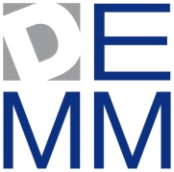 | 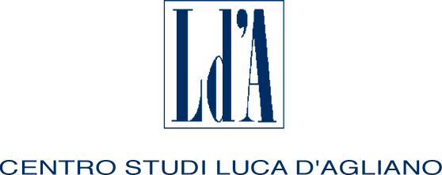 | 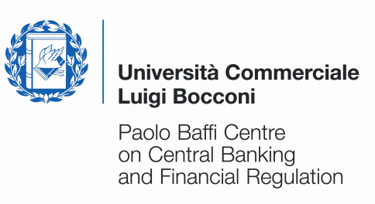 | 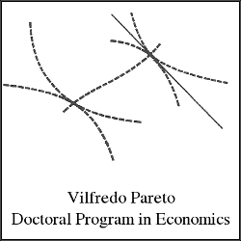  UNIVERSITA’ DEGLI STUDI DI TORINO
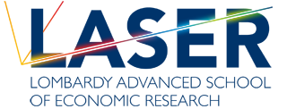 |  | 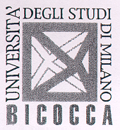

THIRTEENTH SUMMER SCHOOL

IN INTERNATIONAL AND DEVELOPMENT ECONOMICS

Investment, Saving and Wellbeing

in Developing Countries
Tuesday 10 June to Friday 13 June 2014

University of Milan, Palazzo Feltrinelli, Gargnano (BS), Italy

Application form

First name: | Family name:
Nationality: | Date of birth: |  | Sex:
University:
E-mail address:
Phone: |  | Fax:
Title of dissertation:
Supervisor:
Thesis completion date (past or expected):

I request funding* YES NO
* A limited number of grants is available. Therefore only applicants coming from Developing Countries will be eligible for funding. To obtain the reimbursement applicants must attend the whole course.

Please submit this application along with your CV by March 31, 2014 to: centro.dagliano@unimi.it
The activities of the Centro Studi Luca d’Agliano are supported by

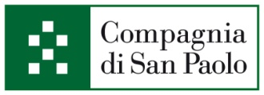
www.dagliano.unimi.it

